Advanced Deep Learning Architectures for Automated Crop Disease Diagnosis: A Comprehensive Analysis of State-of-the-Art Models, Datasets, and Field Deployment Challenges

Rauneet Raj Bachelor of Technology (CSE) Lovely Professional University
Phagwara, Punjab, India rauneet234@gmail.com
Vishal Kumar Yadav Bachelor of Technology (CSE) Lovely Professional University
Phagwara, Punjab, India vishalyadav382003@gmail.com
Aditya Pratap Singh Assistant Professor (CSE), Lovely Professional University Phagwara, Punjab, India singhaditya52508@gmail.com
Ashutosh Kumar Pathak Bachelor of Technology (CSE) Lovely Professional University
Phagwara, Punjab, India ashu123sachin@gmail.com
Nitesh Kumar Bachelor of Technology (CSE) Lovely Professional University
Phagwara, Punjab, India niteshrajly@gmail.com
Suhel Bachelor of Technology (CSE) Lovely Professional University Phagwara, Punjab, India Suhelrao2004@gmail.com

Abstract—Poor product yields are a result of diseases in the crops especially where they are not detected early enough. Traditional visual inspection not only is slow, but also inaccurate and purely image-based deep learning models are ineffective in the sector. A system I would recommend in this paper is the multimodal system, which is achieved by analyzing the leaf-images and the environmental data, such as the temperature, humidity, and rainfall. The disease is detected with the help of a CNN, whereas the future risks are predicted with the help of the time-series model. The system provides elucidable heatmaps and treatment recommendations. Experiments show that visual and environmental information when combined will increase accuracy, reduce false detections and make more reliable and sustainable agricultural decisions.

1. INTRODUCTION

1. 1 The Worldwide Call to Automated Disease Detection.
The agricultural sector is the backbone of the world economy and the main livelihood of a significant number of people in the world especially the Global South. Nevertheless, the industry is facing an
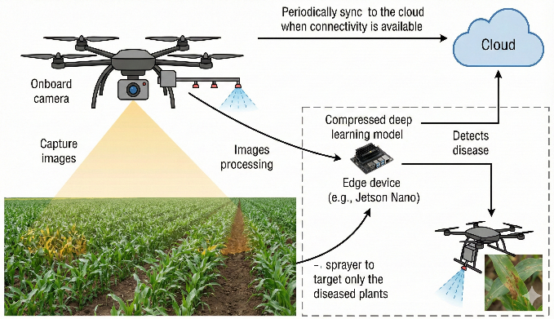
Fig. 1. Overview of an automated crop disease detection system integrating edge devices and cloud computing [2].
existential crisis: the requirement to grow food production radically to satisfy the nutritional demands of an estimated 9.7 billion individuals by 2050 and, at the same time, grapple with shrinking arable land, water scarcity, and the accelerating effects of the climate change.1 Climate change, in its turn, is causing a fundamental transformation in the epidemiology of plant diseases, as it is extending the geographical scope of the pathogens and vectors and making the previously resistant crop strains susceptible. Plant diseases and pests are one of the most widespread and harmful food security threats. This represents a direct economic cost to developing countries (annually, these losses are approximated to cost economies over 220 billion dollars), causing severe losses to agriculture as a sector, and greatly contributing to poverty and food insecurity in developing countries since in many cases, agriculture constitutes a huge portion of the GDP of developing nations. The conventional model of disease control is based on visual observation by plant pathologists or agricultural extension officers. Although human knowledge cannot be overvalued, this method is by definition unscaled and full of restrictions. It is limited by the fact that there is a massive shortage of qualified experts compared to the number of the farmers, human visual diagnosis is subjective and can cause inter-observer variability and the logistical issues that may arise by having to monitor extensive agricultural lands. This practice does not only escalate costs of inputs among financially constrained farmers, but also leads to high levels of environmental degradation, deaths of useful non-target organisms, and emergence of pesticide-resistant strains of pathogens hence creating a vicious cycle of vulnerability.

1.2 The Merging of Artificial Intelligence and Agriculture.
The Artificial Intelligence (AI) and especially the Computer Vision (CV) branch has become a groundbreaking way out of such systemic issues. Deep Learning (DL) models are able to examine digital images of plant leaves to detect faint patterns of symptoms (e.g. early-stage lesions, chlorosis, and necrosis) frequently at higher consistency and speed than human observers by simulating the human visual cortex neural structure. The history of technological change in this field has been fallacious. Initially, methods were based on classical image processing methods and features that were hand-crafted and fragile to generalization. The inspiration of Deep Convolutional Neural Networks (DCNNs) was a game changer, as the model allowed end-to-end learning, in which the model was able to automatically learn the relevant features of raw pixel information. Probably more recently, the research has seen the emergence of Vision Transformers (ViTs) and hybrid models that utilize self-attention architecture to capture long-range dependencies and context image-wide, and further extend the limits of diagnostic error.10 Nevertheless, AI is potentially useful in agriculture more than just detection. Real-time monitoring and intervention systems are becoming a possibility as these diagnostic models are being integrated with Internet of Things (IoT) devices, autonomous drones, and robotics. These systems may facilitate the variable rate technology, where the agrochemicals are deposited on the affected plants not on the whole fields and this has a great benefit of reducing the level of chemicals applied and the operation costs.²

1.3 the Problem Statement and Research Gap
Despite Although the academic literature claims that the accuracy of DL models is high, typically in the 99% range on standard datasets, the existence of a large deployment gap is seen as a major barrier to adoption because most current models are trained and tested on curated, laboratory quality datasets such as those provided by Plant-Village, in which images are taken under controlled conditions (light), at constant distance, and on homogeneous backgrounds.14 When these models are brought to the actual agricultural conditions, commonly known as in-the-wild conditions, the performance of the models worsens exponentially. Field conditions present a multiplicity of confounding factors: complicated, disheveled backgrounds, fluctuating natural light conditions (shadows, overexposure), being obstructed by other leaves, different angles of view, and the co-occurrence of multiple biotic and abiotic stressors (e.g., nutrient deficiency and fungal infection).16 A domain shift between diverse and cluttered reality with clean training data is impossible to bridge by current models. Moreover, the processing requirements of state-of-the-art models such as ViTs and deep Res-Nets are also a significant impediment to implementation in rural agricultural settings. Such areas frequently include the lack of a high-speed internet connection to perform cloud-based inference and the use of dense models on edge devices (like smartphones or IoT sensors) consumes energy and surpasses bandwidth limitations, which in turn encourages the need to thoroughly explore model compression methods (quantization and pruning) and the creation of lightweight architectures (TinyML) that can execute programs without an internet connection (offline).20 and also, the issue of data privacy and the proprietary nature of agricultural data has limited the uptake of collaborative, large-scale training programs.²²

1.4 Objectives and Scope
The purpose of this research report is to critically discuss the state of AI-based detection of crop diseases in a holistic and expert-level manner. We no longer report on performance, but break down the mechanisms, constraints, and possibilities of these technologies in the future. The targeted goals to be used in this analysis are:
- Architectural Evaluation: To harshly critique and contrast the effectiveness of current deep learning architectures, beyond conventional CNNs (Res-Net, Dense-Net, Efficient-Net) to new Vision Transformers and Hybrid models, providing a clear examination of their inductive biases and applicability to agricultural images.
- Data Ecosystem Analysis: To critically examine the weaknesses of existing datasets and ask the question of how can the utility of controlled data and in-the-wild data be compared and how can synthetic data generation (GANs) and advanced augmentation be used as solutions to address data scarcity and enhance robustness. Deployment Methodologies: To explore the technical issues and remedies of deploying AI models on resource-limited edge devices, specifying the specific techniques in quantization, pruning, and the use of hardware accelerators.
- Deployment Methodologies: To explore the technical issues and remedies of deploying AI models on resource-limited edge devices, specifying the specific techniques in quantization, pruning, and the use of hardware accelerators.
- Emerging Paradigms: To reach the edge of agricultural AI, such as Multimodal Learning (text and image), Federated Learning to collaborate inside privacy-preservation, and the use of Large Language Models (LLMs) to provide explainable diagnostics.

2. Associated Work and Theoretical background.
The Automated plant disease detection is a field that has experienced a fundamental evolution process over time, which is reflective of the wider course of development in computer vision. This historical and theoretical background is very important to understand the capabilities and limitations of modern architectures. The history of using deep learning to produce images has its origin in the era of hand-crafted features.

2.1 Deep Learning History Developed out of the Hand-Crafted Features.
Prior Before the epoch of deep learning (around 2012), computer vision in the agricultural field was dominated by the classical image processing methods and shallow machine learning algorithms. This process normally included a series of processing steps: image pre-processing (noise removal, resizing), image segmentation (to isolate the leaf as opposed to the background), feature extraction, and, lastly, classification.¹
During the stage of extracting the features, the researchers used the so-called hand-crafted descriptors. These included:
- Colour Features: Histograms To identify the characteristic color of necrotic spots or chlorosis a histogram of pixel values in different color spaces (RGB, HSV, LAB) was used to identify the distinct color value of those spots.
- Texture Features: Descriptors The surface texture of the leaf and lesion were measured using the Gray Level Co-occurrence Matrix (GLCM), Gabor filters, and Local Binary Patterns (LBP).²⁵
- Shape Features: Geometric characteristics such as area, perimeter and solidity were computed to describe the morphology of the disease spots.²⁴
derived feature vectors were then inputted into a classifier (Support Vector Machines (SVMs), K-Nearest Neighbors (KNN), Random Forests, or Artificial Neural Networks (ANNs)) but they had serious weaknesses. They needed a very strong domain knowledge to design features which were relevant to each disease-crop pair, and they did not have the capacity of generalizing. The feature set that would work well on rusty wheat is not going to work at all on blighty potatoes. Moreover, being incredibly susceptible to changes in lighting and background, the means required stringent image segmentation, and the latter is a complicated task in the field.¹

2.2 The CNNs, the Deep Learning Revolution: Convolutional Neural Networks (CNNs)
The The advent of Convolutional Neural Networks (CNNs) changed everything since it has made the process of features extraction automatic. In contrast to the classical algorithms, CNNs acquire hierarchical data representations on raw pixels. The simpler features such as edges, corners and color gradients are captured in the lower levels of a CNN, and higher levels combine them to complex and semantic features, such as lesions, vein patterns or fungal spores.⁵ This end-to-end nature of learning has made CNNs the default of image classification tasks in agriculture.⁸
CNNs consist of the basic building blocks of:
- Convolutional Layers: The convolutional layers involve the use of a series of learnable filters (kernels) on the input image. When the filter moves (convolves) through the image, the filter does element multiplication and summation to form feature maps which emphasize certain patterns.
- Pooling Layers: Pooling (e.g., Max Pooling or Average Pooling) halves the number of spatial dimensions of the feature maps, which makes the network a fixed point of small translations and enables the network to save on computation time.
- Activation Functions: Non-linear functions such as Re-LU (Rectified Linear Unit) are proposed to enable the network to approximate non-linear functions which are quite complex.⁹
Since the breakthrough of AlexNet in 2012, several CNN architectures have been adapted for plant disease detection, each introducing architectural innovations to improve accuracy and efficiency.
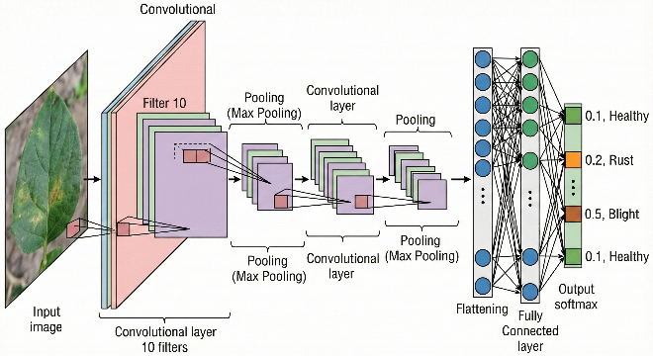
Fig. 2. Operational flow of a Convolutional Neural Network (CNN) showing feature extraction through filtering and pooling layers [5].

2.2.1 Residual Networks (Res-Net)
As Later networks started experiencing the vanishing gradient phenomenon, and the farther away they were, the less the signal they needed to update weights, thereby terminating the learning process. The Res-Net (Residual Network) presented by He et al. solved this issue by adding so-called skip connections or residual blocks.14 The residual connection enables the gradient to pass through the network with less resistance. ResNet-50 and ResNet-101 have become a common backbone in the context of crop disease detection. This is because they can learn very discriminative characteristics of distinguishing between visually related diseases due to the ability to train very deep networks. Results using ResNet-50 to the Plant-Village dataset have shown a consistent accuracy of 98-99% thus making it a good baseline to compare with.9

2.2.2 Densely Connected Networks (Dense-Net)
The concept of connectivity is extended by dense-Net (e.g. DenseNet-121). A Dense-Net block is a feed-forward network whereby one layer is connected to all the other layers. Each layer is fed with the feature maps of all the previous layers, which are concatenated. This architecture is the most information-effective in terms of information flow and promotes feature reuse, which makes the network highly parameter-efficient in comparison to ResNet.14
Agricultural research has demonstrated that in comparison with ResNet-50, DenseNet-121 can be more efficient in the discrimination of subtle disease symptoms, which can sometimes be more effective than ResNet-50. As an illustration, DenseNet-121 in a horticultural crops study had an accuracy of 99.81, thus showing that it can deal with high inter-class similarity.9

2.2.3 Efficient-Net
While Whereas Res-Net and Dense-Net were depth- and connectivity-oriented approaches, Efficient-Net proposed so-called compound scaling. It simultaneously optimizes the width (number of channels), depth (number of layers) and resolution of a network with a given set of scaling coefficients fixed. This leads to models with state of the art accuracy, with much fewer parameters and FLOPs (Floating Point Operations) than those before.

The models of the Efficient-Net (B0 to B7) are especially applicable in the field of agriculture where the resources of the computations are not uniform. An example of such an architecture is EfficientNet-B3, which has also been shown to generalize better than older architectures, such as on difficult datasets like Plant-Doc, and with higher accuracy-to-parameter ratios.28

2.3 Vision Transformers (ViTs) Rising.
Although CNNs are highly effective at extracting local features (because of their inductive bias (translation invariance and locality), they are also historically weak at learning long-range information in an image because of their fixed receptive fields. A CNN may identify a lesion, but may have difficulty with determining what spatial relationship exists between the lesion and the tip of the leaf which may be diagnostic of some diseases. ViTs are an alternative to the convolutional paradigm. ViTs were developed based on the Transformer architecture that transformed Natural Language Processing (NLP) by viewing an image as a sequence of patches, just like words in a sentence.11
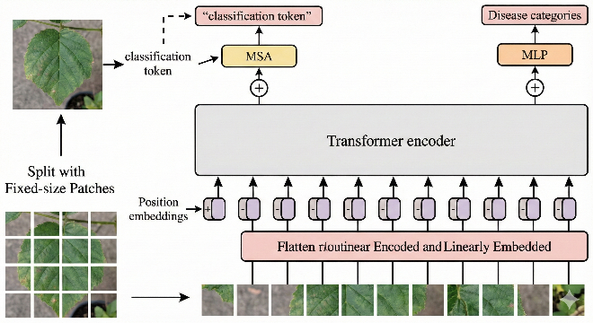
Fig. 3. Architecture of the Vision Transformer (ViT) utilizing fixed-size patches and a classification token for disease diagnosis [11].

2.3.1 Self-Attention Mechanism
The attention mechanism is the main part of the ViT. This enables the model to attach the relevance of various image patches with respect to one another without considering the distance between them. On each patch of the image, the mechanism computes an attention score on each other patch, which enables the model to have the ability to combine information about the entire leaf surface in case of systemic infections where the symptoms may be located over the entire surface or a spatial pattern of the spots may be a significant identifying factor.⁸

2.3.2 ViT Agriculture Performance.
Recent According to recent benchmarking papers by 2024 and 2025, ViTs have been shown to be better than CNNs in crop disease classification especially when there is a large amount of data or the symptoms of disease are distributed globally. A comparative study of Rice, Tea, and Maize disease, ViT-30 was found to have an average accuracy of 98.41 and 96.95 on Rice and Maize datasets respectively, which is higher than the traditional CNN baselines, but ViTs tend to be less inductive biased than CNNs. To avoid overfitting, they generally need more data or substantially large pre-training, which can be difficult in agriculture where labeled data may be limited.³⁰

3. GLOBAL DATA SET ANALYSIS: THE BASIS OF MODEL EFFECTIVENESS
Quality and diversity of the data that is used to train any deep learning model are inseparably employed in performance, reliability, and generalization ability of such a model. The data landscape in the area of plant disease detection includes a serious dichotomy of the high-quality, controlled laboratory data and sparse, noisy field data.

3.1 Controlled Environment Datasets: The Plant-Village Benchmark
The most impactful and factual reference in agricultural computer vision is the PlantVillage dataset, which is the most utilized. It contains more than 54,305 images and 38 different class labels (including 14 crop species, including apple, blueberry, corn, grape, peach, pepper, potato, raspberry, soybean, squash, strawberry and tomato) and has been used to standardize model evaluation and demonstrate the viability of AI-based diagnosis.⁹
Characteristics:
- Controlled Lighting: Photographs are made in the same, artificial light, in which shadows and time of day or weather changes are removed.
- Uniform Backgrounds: Most leaves are segmented or placed against a neutral grey or black background, removing background clutter.
- Single Leaf Focus: The image is usually a single leaf, the leaf is centered and flattened, eliminating the problems of occlusion and scale.
Critique and Limitations:
While although, with Plant-Village, it is possible to create highly accurate models (routinely >99%), it has a disadvantage in its simplicity, which is a two-sided sword. Plant-Village trained models based on simplified features are built to depend on a simpler cue, like the background color or the lighting gradient, but not strong and invariant disease features. The effect of this phenomenon is failure of domain shift. In practice, the accuracy of a model when trained on Plant-Village degrades by 20-30 percent or more when tested on images of a real field, which is why the model is not reliable in the field application.13

3.2 Field Condition Datasets: Overcoming the Reality Gap.
In order to overcome the dismal constraints of controlled datasets, the research community is paying more and more attention to the creation of the so-called in-the-wild datasets that represent the complexity of the agricultural environment.

3.2.1 Plant-Doc
Plant-Doc is a very important move towards realistic benchmarks. It has 2,598 images sourced online and representing 13 plant species and 27 classes.³³
- Reality Factors: In PlantDoc, the images have natural backgrounds, several leaves and images are of different resolutions and different lighting conditions.
- Benchmarking Impact: Studies It has been revealed that models with >99% precision in PlantVillage can reduce to about 70-80% in PlantDoc. The decrease in performance is a measure of this reality gap and identifies that more powerful feature extraction methods should be employed.²⁹

3.2.2 PlantWild
Plant-Wild is a more recent and larger scale dataset, which aims to challenge the current recognition abilities. It covers a wider set of categories and, most importantly, is rich with written comments of each category.³⁵
- Difficulty: It It is severely difficult with issues of proper detection of disease regions amid complex, mottled backgrounds (soil, weeds, machinery), significant disparities in intra-class look (a disease appearing dissimilar in a variety of development phases), and minor inter-class errors (a disease appearing extremely similar).³⁵

3.3 Specialized Crop Datasets
Beyond general benchmarks, specialized datasets are critical for specific agricultural sectors.
- PaddyDoctor: A This is a full dataset of rice disease, with models that have been trained with accuracy up to 99.0 percent, a benchmark to one of the staple crops in the world.³⁴
- RoCoLe (Robusta Coffee Leaf): It is characterized by its imbalance and lower number of samples (around 1,560 images), which requires more sophisticated ways of augmenting images such as CycleGAN to obtain usable results.³⁴
- Cassava Leaf Disease: This dataset has 5,656 images and focuses on Cassava, an important food security crop in Africa, and poses a problem of fine-grained disease classification.³⁴

3.4 Data generation and Synthetic generation.
Data augmentation and synthetic data generation are the key to researchers due to the high cost and difficulty of collecting large-scale, annotated field data.

3.4.1 Advanced Augmentation Libraries
Simple geometric transformations include rotation, flipping, and are known as standard augmentation. More aggressive augmentations however are needed to achieve strong performance on the field.
- Albumentations vs. Torchvision: Albumentations is a better agricultural CV tool than Torchvision which is the standard library of PyTorch. It also provides more rapid and varied set of transformations, such as elastic deformations, grid distortions, and more sophisticated color shift operations, which are more realistic in replicating the biological variability of plant leaves and environmental conditions and are thus more effectively applied to object detection tasks, a more complex operation to perform manually in Torchvision. ³⁷

3.4.2 Generative Adversarial Networks (GANs) are another type of AI technologies employed in this context.
Generative Generative Adversarial Networks (GANs) are finding more applications in combating data shortage and imbalance in classes. A GAN is made of two neural networks known as Generator and Discriminator which compete with each other. The Generator generates the images which are synthetic and the Discriminator attempts to differentiate between the manmade and real images. With time the Generator is trained to generate images that are statistically indistinguishable of real ones. ³⁹
Key Applications:
- Balancing Datasets: GANs can produce thousands of fake images of uncommon diseases, either incur the class imbalance or avoid ability of the model to bias to the majority healthy class.⁵
- Domain Adaptation (CycleGAN): Cycle-GANs are capable of paired example-free domain to domain translation. An example is to learn the texture and lighting behaviour of a field environment and use it to convert a clean image of a laboratory into a noisy field image. This will enable the researchers to utilize the size of PlantVillage to prepare the conditions of the PlantDoc.²⁹
- Super-Resolution: GANs can also be used to complement low-resolution images taken with low-end smartphones with fine-grained texture features needed to accurately diagnose them. ⁴¹
Table 1: Comparison of Key Agricultural Disease Datasets
Dataset | Images | Classes | Environment | Key Challenges / Utility
PlantVillage | 54,305 | 38 | Controlled (Lab) | Lack of background noise; good for initial benchmarking
PlantDoc | 2,598 | 27 | In-the-Wild | Complex backgrounds; tests robustness
PaddyDoctor | ~16,000 | 13 | Field (Rice) | Fine-grained rice diseases; specialized benchmark
RoCoLe | 1,560 | 6 | Field (Coffee) | High class imbalance; good for augmentation research
PlantWild | Large | 89+ | In-the-Wild | Extreme variance; multimodal annotations; tests generally

4. Graphical network of Disease Detection
In this section, the main architectures applied in recent research are compared in more detail and their structural benefits and performance indicators are disaggregated.

4.1 THE FOURTH COMPONENT IS THE CONVOLUTIONAL NEURAL NETWORKS (CNNS)
The CNNs are still the staple of computer vision in agriculture. Their visual nature of plant diseases perfectly coincides with their hierarchical feature learning ability.

4.1.1 Residual Networks (Res-Net)
Res-Net is the standard in the industry in terms of accuracy and the cost of computing.
- Mechanism: It makes use of residual blocks with skip connections (y 0 F(x) + x) to ease gradient flow.
- Performance: ResNet-50 has been shown to perform well on Plant-Village, with accuracy above 98% on average. ⁹ but has a relatively large number of parameters (about 25M) that can be a memory bottleneck when un-optimized and deployed in a mobile context.

4.1.2 Densely Connected Networks (Dense-Net)
Dense-Net links all the layers to the rest of the layers in a feed-forward manner.
- Mechanism: It uses concatenation of feature maps ($y = [x_0, x_1..., x_{l-1}] $) rather than summation. This produces a knowledge collective in the network.
- Performance: DenseNet-121 has demonstrated very high performance in distinguishing similar diseases in visual representation, with an accuracy of 99.81 at some points, it is parameter-efficient (about 8M parameters) and, however, consumes a lot of memory when training: it requires concatenation operation.

4.1.3 Efficient-Net and Scalable Architectures
Efficient-Net was the current technique in CNN design which considers efficiency.
- Mechanism: It is a compound scaling approach that scales uniformly network width, depth and resolution.
- Performance: The spectrum of options is in EfficientNet-B0 to B7. EfficientNet-B3 has been noted to generalize better on the Plant-Doc data than Res-Net, being more accurate with fewer parameters.²⁹

4.2 Vision Transformers (ViTs)
ViTs are threatening to replace CNNs with an alternative inductive bias: the global context.

4.2.1 Mechanism of Self-Attention
ViTs in contrast to CNNs do not process pixels in local neighborhoods, they instead break up an image into uniformly sized patches (e.g. 16x16 pixels) and flatten them before embedding them linearly.
These embeddings are then processed by a self-attention mechanism which enables the model to pay attention to any part of the image based on any other part.¹¹ This global receptive field is especially beneficial in detecting disease patterns, which are defined by how they appear throughout the leaf and not on its local texture.

4.2.2 ViT Performance in Agriculture
According to current research (2024-2025), ViTs can be used to surpass CNNs in large datasets. As an example, a ViT-30 model has 98.41% accuracy on a dataset of Rice Leaf, which is better than the standard CNNs. ⁸ but ViT is more computationally expensive and slow to converge on small, specialized data without transfer learning.³⁰

4.3 Hybrid Architectures
Hybrid models aim to integrate the advantages of the two worlds: the local nature of feature extraction of CNNs and the global nature of Transformers.
- CNN-Transformer Hybrids: Models like ConvTransNet-S use convolutional layers for the initial stages to extract low-level features (edges, textures) and then pass these feature maps to Transformer blocks to model long-range dependencies. This design captures both the texture of the lesion and its context on the leaf.⁴²
- Performance: Such These hybrids have been shown to attain state-of-the-art accuracy (e.g., 99.62) even on background-complex datasets, and have effectively overcome the shortcomings of the pure CNNs or pure ViTs.³¹
- Attention Modules: Lighter Lighter hybrid methods Lighter hybrid methods can be seen as insertion of attention modules (such as CBAM or SE-blocks) into CNNs. These modules are taught to change the importance of feature channels, and effectively tell the network to actually pay more attention to the texture channel but less attention to the background color channel. This introduces negligible computation benefit and a big-time performance enhancement on tiny-scale classification problems.⁴³
Table 2: Comparative Analysis of Model Architectures for Crop Disease Detection
Architecture | Parameters (M) | PlantVillage Acc. (%) | PlantDoc Acc. (%) | Pros | Cons
ResNet-50 | ~25.6 | 99.30 | ~70-75 | Stable baseline; widely used | Heavy for edge; fixed receptive field
DenseNet-121 | ~8.0 | 99.81 | ~75-78 | Parameter-efficient; feature reuse | High memory usage during training
EfficientNet-B3 | ~12.0 | 99.5+ | ~80.1 | Excellent acc-vs-efficiency tradeoff | Complex tuning
MobileNetV3 | ~2.5 | 99.50 | ~65-70 | Fast; designed for mobile/IoT | Lower capacity for complex patterns
ViT (Base) | ~86.0 | 98.41 | ~78-82 | Captures global context; handles occlusion | Data-hungry; heavy computation
Hybrid (CNN+ViT) | Varies | 99.62 | ~85+ | Robust to background; combines local+global features | Complex design; high training cost

5. METHODOLOGICAL FRAMEWORKS AND TRAINING STRATEGIES
The creation of an effective crop disease detection system does not only require the choice of an architecture. The training methodology, loss functions, and optimization strategies are also very crucial. The process of pre-processing and feature engineering addresses the pre-processing and feature engineering phases, respectively.

5.1 pre-processing and feature engineering processes are considered respectively.
The initially effective defense against noise is good pre-processing.
- Resizing and Normalization: Image is normally re-sized to standard size (e.g. 224x224 in ResNet). Normalization (minimization of the means, division by standard deviation) will lead to faster convergence.
- Background Removal: In Segmentation algorithms (such as the thresholding of Otsu or U-Net) may be utilized to remove the background in advance before classification to have the model focus on the leaf alone.⁴⁰
- Color Space Conversion: As colors can be used to define certain symptoms, such as chlorosis, the colors can be converted to HSV or LAB color spaces to enhance the visibility of certain symptoms.²⁴

5.2 Loss Functions for Class Imbalance
The functions of loss to deal with class imbalance in Class Imbalance are condensed into sub-functions as illustrated in the figure below. Field data is unbalanced in nature. There may be 1000 safe images of normal healthy leaf but just 50 of some rare blight. None of the models can be trained with a Standard Cross-Entropy because this criterion will encourage the model to predict "healthy" so that it can reduce the global error.
- Focal Loss: The loss function follows the same principle whereby easy examples (healthy leaderships that get classified) are given less weight and training is refined to focus on the hard negative cases (rare diseases that should be detected but aren’t). $FL (pt) = -\alpha(1-pt) Janine log(pt). The model is made to learn the rare classes by varying the focusing parameter, in this case, the parameter is the use of the gamma.⁴⁵
- Generalized Dice Loss: For In segmentation (finding the pixels that contain the disease), the Dice Loss is a better metric than pixel-wise cross-entropy since it directly maximizes the Intersection over Union (IoU), which is sensitive to the discrepancy between the small lesion region and the large background area.⁴⁷

5.3 Optimization and Hyperparameters
- Optimizers: Adam (Adaptive Moment Estimation) and SGD (Stochastic Gradient Descent) momentum These are both industry standards. Usually, Adam can be selected because of the faster convergence, although SGD tends to have a little better generalization error in the long-term.
- Learning Rate Schedulers: Learning rate methods such as Cosine annealing or Reduce LR on Plateau are necessary. Using a high learning rate, they are initially able to traverse the loss landscape fast and then decrease the rate to stabilize at a global minimum.⁸
- Transfer Learning: It is hardly possible to train without starting at the beginning. Transfer learning= ImageNet weights initialization is universally used. Strategies based on fine-tuning usually use freezing the initial layers (which identify generic edges) and retraining the further layers (which identify a specific biological texture).⁹

5.4 Evaluation Metrics
Algorithms based on mere accuracy are deceptive in skewed data sets.
- F1-Score: The harmonic mean of precision and recall. An F1-score must be high to guarantee that the model is reliable (high precision) and sensitive (high recall).⁹

- Precision vs. Recall Trade-off: When it comes to agriculture, Recall is used a lot. Loss of disease (False Negative) may result in an epidemic, but a False Alarm (False Positive) may only result in wastage of a small portion of pesticide.⁴⁸
- Intersection over Union (IoU): is an important metric in detection problems, which quantifies the area of intersection between the predicted disease area, and the true disease area.⁴⁸

6. DEPLOYMENT STRATEGIES: EDGE AI AND TINYML
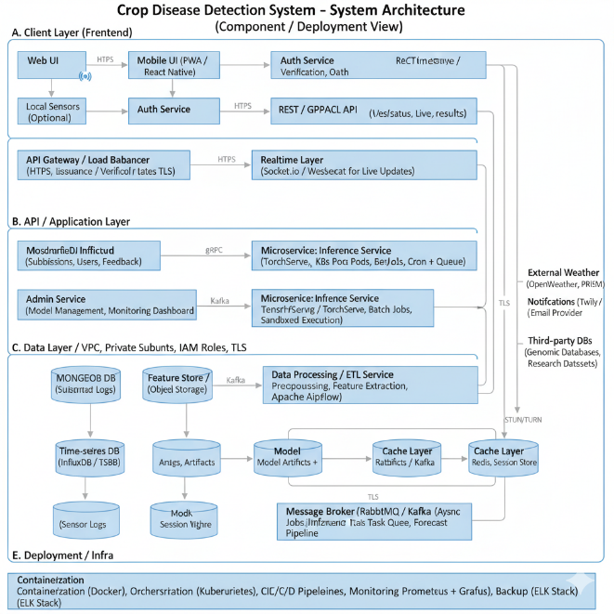
Fig. 4. Proposed system architecture illustrating the Client, API, and Data layers designed for scalable field deployment.
In order to help an average farmer, AI will have to be run on a hardware that is available. Although cloud-based inference is a powerful tool, it requires an internet connection that is not very stable or absent in the countryside. This demands Edge AI or Tiny-ML - executing models on-the-job in devices such as smartphones, drones or Raspberry Pis.

6.1 Challenges of Field Deployment
- Latency: Milliseconds inference times are needed to detect (e.g. when spraying a drone) in real-time. Slow heavy models such as VGG16 (500MB+) are too slow.
- Energy Consumption: Battery-powered the power consumption of the complicated GPU calculations cannot be maintained with battery-powered devices.
- Memory Constraints: Edge devices typically have a small amount of RAM (e.g. 2GB in a Raspberry Pi 4, KB in microcontrollers), which cannot store big models.¹⁸

6.2 Model Compression Techniques are as follows.
In order to fill this gap model compression is necessary.
- Quantization: This is the process of quantizing the weights of the model to have 8-bit integers (INT8) or 16-bit floats (FP16) instead of 32-bit floating-point numbers (FP32). Quantization of the model after training can trim down the model size 4x with insignificant error (as little as 1 percent). To scale (such as quantizing MobileNet models), a native usability example of a 2.13x inference improve point has been demonstrated on edge-based hardware, such as Intel NCS2.⁵⁰

- Pruning: Pruning is the process of finding and eliminating the redundant neurons or connections that add small contribution to the output. Hardware acceleration is desirable as structured pruning (eliminating whole filters). It is demonstrated that the pruning of a DenseNet-40 model can cut parameters by more than 75 percent and computations by more than 65 percent, with the model scoring above 97 percent accuracy.⁵²
- Knowledge Distillation: A large, pre-trained "Teacher" model guides the training of a smaller "Student" model, transferring its generalization capabilities to the lighter architecture.

6.3 Hardware Accelerators in Agriculture
Special hardware is needed to deploy these compressed models.
- Raspberry Pi & Jetson Nano: The Raspberry Pi 4 is a popular low-cost option, often paired with accelerators like the Google Coral USB Accelerator (Edge TPU) or Intel Neural Compute Stick (NCS2). These are ASICs that were developed to perform central operations such as tensors, allowing real-time inference (30+ FPS) on low-power devices.⁵⁰
- Microcontrollers (MCU): Platforms like Edge Impulse allow deploying extremely lightweight models (TinyML) onto microcontrollers (like the ESP32 or Arduino Nano BLE Sense). Although these are limited to very simple models (e.g. MobileNetV1-0.25), they are extremely low power and capable of operating over months on a battery.²¹ Comparative analysis has revealed that, although TensorFlow is flexible, Edge Impulse is a simplified pipeline to execute models on these particular MCUs.⁵⁴

7. EMERGING PARADIGMS: PRIVACY AND REASONING

7.1 Federated Learning to Preservation of Privacy.
The primary obstacle of constructing strong world models is data silos. Farmers and agribusinesses are not always willing to give proprietary crop data. Federated Learning (FL) provides a solution to this by using decentralized devices to train the model.
- Mechanism: Instead of sending data to a central serverThe client trains the model using its local and private data and transfers the model updates only (gradients) to the server. The server combines these updates (e.g. by Federated Averaging) to enhance the global model.⁵⁵
- Impact: Recent applications in tea and tomato disease diagnosis have shown that FL can be competitive (e.g., 93.5%) with respect to centralized training and that raw data do not move out of the farm.²³
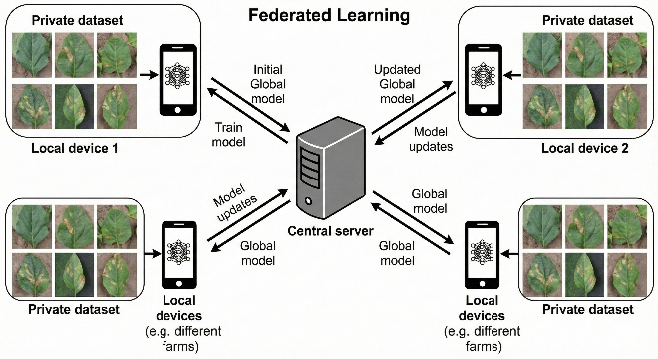
Fig. 5. The Federated Learning framework enabling decentralized model training across private local datasets [55].

7.2 Multimodal Learning and Large Language Models (LLMs)
The border of 2025 is merging the sight and the word.
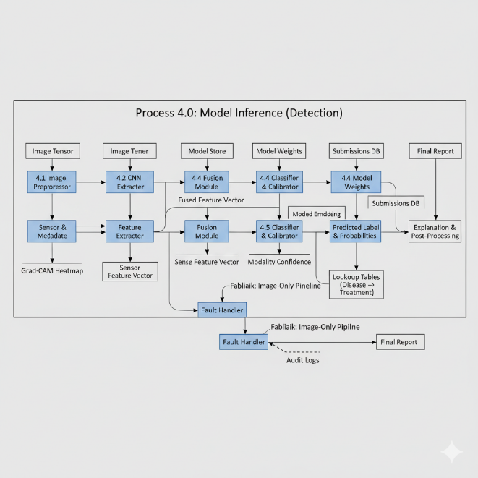
Fig. 6. Data Flow Diagram (DFD) for the multimodal inference process, demonstrating the fusion of visual features with environmental sensor metadata.
- CLIP (Contrastive Language-Image Pre-training): CLIP models are capable of doing zero-shot classification i.e. by finding images corresponding to a natural language description (e.g., image of a leaf with apple scab). This enables the identification of novel diseases that the model was not explicitly trained to identify, and provides a solution to the novel pathogen problem.¹³
- GPT-4o and Vision-Language Models: Fine-tuning multimodal models (such as GPT-4o) cannot just classify the disease (e.g., Apple Scab), but can provide a written explanation of the symptoms and suggest treatment. Though performing at zero-shot worse than specialized CNNs, fine-tuned multimodal models have reached up to 98.12% with the added perks of interpretability.⁵⁸

8. DISCUSSION AND FUTURE DIRECTIONS
AI-based crop disease detection is on a critical crossroad. The issue of categorizing different diseases under controlled laboratory conditions has been solved to a great extent with the errors approaching 99 percent. Nevertheless, the shift to strong and field-deployable systems is still in progress.
Key Challenges:
- Generalization: The biggest bottleneck is the domain shift between datasets such as PlantVillage and PlantWild. Future studies should focus on the In-the-Wild data collection and unsupervised domain adaptation methodology.
- Interpretability (XAI): For To build trust on AI, black box decisions are inadequate to farmers. Explainable AI (XAI) algorithms such as Grad-CAM and saliency maps have to be combined so that they can be used to visualize why a model has arrived at the diagnosis, and it is not simply looking at the background.⁴⁶

- Sustainable AI: The bigger the models are (e.g. Transformers), the larger their energy footprint. Green AI is aimed at building energy-efficient architectures with carbon cost of training and inference as low as possible, which is essential to sustainable agriculture.⁶¹

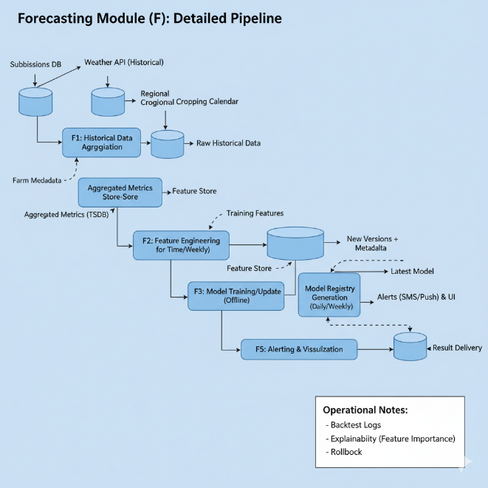
Fig.7. Detailed pipeline for the proposed forecasting module, utilizing historical weather data and cropping calendars for predictive analytics.
Future Outlook:
The future is Hybrid Intelligence - systems that combine the power of pattern recognition of ViTs/CNNs and reasoning of LLMs with the privacy assurances of Federated Learning. We are also headed on the way to the Holistic Plant Health Monitoring systems, which will incorporate visual measurements together with soil sensors, weather sensors and historical data to give an extensive diagnosis, as a doctor does with blood tests and physical examination.

9. CONCLUSION
The current research has summarized a large amount of up-to-date work in order to prove that Deep Learning has radically changed the environment of crop disease diagnostics. On the one hand, it could be ResNet-50, with its solid architectural foundations, on the other hand, it could be Vision Transformer, with its awareness of the world around it, and MobileNetV3, with its efficiency.
Nonetheless, there still exists the deployment gap. The dependence on edited datasets has obscured the problems of field use. The way forward is a concerted data change to data diversity, use synthetic data, more sophisticated augmentation and messy in-the-wild benchmarks. At the same time, Edge AI is the key to the democratization of this technology. With the art of model compression and hardware accelerators, it will be possible to bring an expert level diagnostics to the hands of smallholder farmers on cheap smartphones and IoT devices.
Ultimately, In the end, this technological evolution is not only about academic novelty but even about the practical effect in agriculture: the yield losses should be minimized, the use of chemicals should be minimized, and it should ensure the global food supply under the conditions of the changed climate. This integration of robust, privacy-conscious and explainable AI systems into the agricultural value chain is one of the most promising approaches to achievement of these sustainable development goals.

REFERENCES
- FAO & Global Crop Loss Statistics
  - FAO numbers on the 20-40% loss every year in the worldwide crop production because of pests and diseases and the absence of income amounting to more than 220 billion [1].
  - Population of the world estimated up to 9.7 billion people by 2050 and thus more food will be required [2].
- Datasets
  - PlantVillage: Salathe, M., and Hughes, D. Paolo Zampolli, 2010. The data has 54305 images in 38 classes [3], [4].
  - PlantDoc: Singh, D., et al. "PlantDoc: A Dataset for Visual Plant Disease Detection." Proceedings of the 7th ACM IKDD CoDS and 25th COMAD, containing 2,598 images [5], [6].
  - PlantWild: A large-scale in-the-wild dataset designed to test extreme generalization challenges [7], [8].
  - PaddyDoctor: Petchiammal et al. (2023), a specialized dataset for rice disease detection [5].
- Deep Learning Architectures (CNNs)
  - ResNet: He, K., et al. "Deep Residual Learning for Image Recognition." Benchmarking on PlantVillage often shows >99% accuracy [9], [10].
  - DenseNet: Huang, G., et al. "Densely Connected Convolutional Networks." DenseNet-121 achieved 99.81% accuracy in comparative studies [4].
  - EfficientNet: Tan, M., & Le, Q. "EfficientNet: Rethinking Model Scaling for Convolutional Neural Networks." EfficientNet-B3 achieved 80.19% on PlantDoc, showing better robustness than ResNet [11].
- Vision Transformers (ViTs) and Hybrids
  - ViT Performance: Evaluation of Vision Transformers on Rice, Tea, and Maize datasets, where ViT-30 achieved 98.41% accuracy, outperforming CNNs [12].
  - Hybrid Models: Architectures combining CNNs and Transformers (e.g., ConvTransNet-S) to capture both local and global features [13], [14].
- Deployment and Edge AI
  - MobileNet & Quantization: Implementation of MobileNetV3-small with quantization techniques, reducing model parameters to 0.93 million while maintaining ~99.5% accuracy [15].
  - TinyML: Use of frameworks like Edge Impulse and TensorFlow Lite for deploying models on microcontrollers [16], [17].
  - Hardware Acceleration: Utilizing Google Coral TPU and Intel NCS2 for accelerating inference in agricultural settings [18], [19].
- Data Augmentation and Synthetic Data
  - Albumentations: Buslaev, A., et al. "Albumentations: Fast and Flexible Image Augmentations." Used for advanced geometric and color transformations [20], [21].
  - GANs: Use of Generative Adversarial Networks (FHWD, CycleGAN) to generate realistic synthetic training data for rare diseases [22], [23].
- Emerging Paradigms
  - Federated Learning: Frameworks of privacy-preserving disease diagnosis of tea and tomato crops [24], [25].
  - Multimodal LLMs: Zero-shot and few-shot disease classification with GPT-4o and CLIP [26], [27].

